**Create Global class in se24**

1. Go to se24.
2. Give class name starting with ZCL_. Click on create

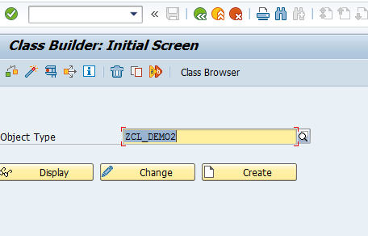

1. Give short description , choose Public and click Save

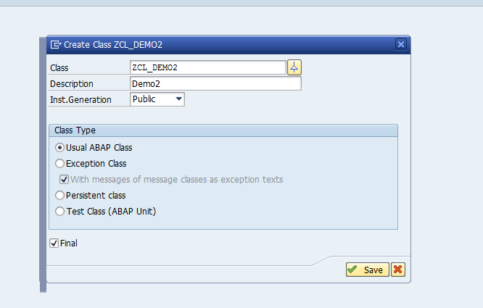

1. Go to Methods tab. Declare 2 methods add and subtract as shown below

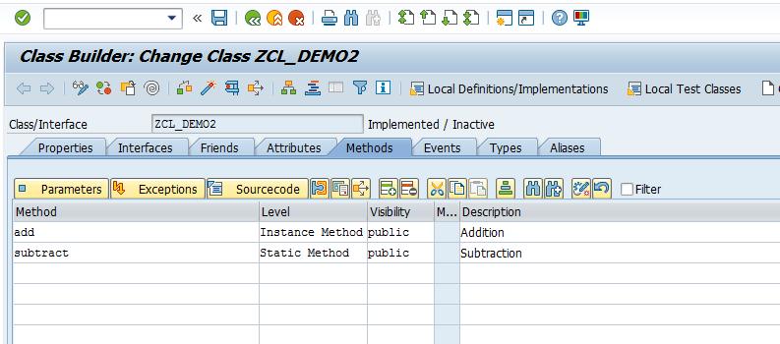

1. Keep the cursor on Method add and click on source code.

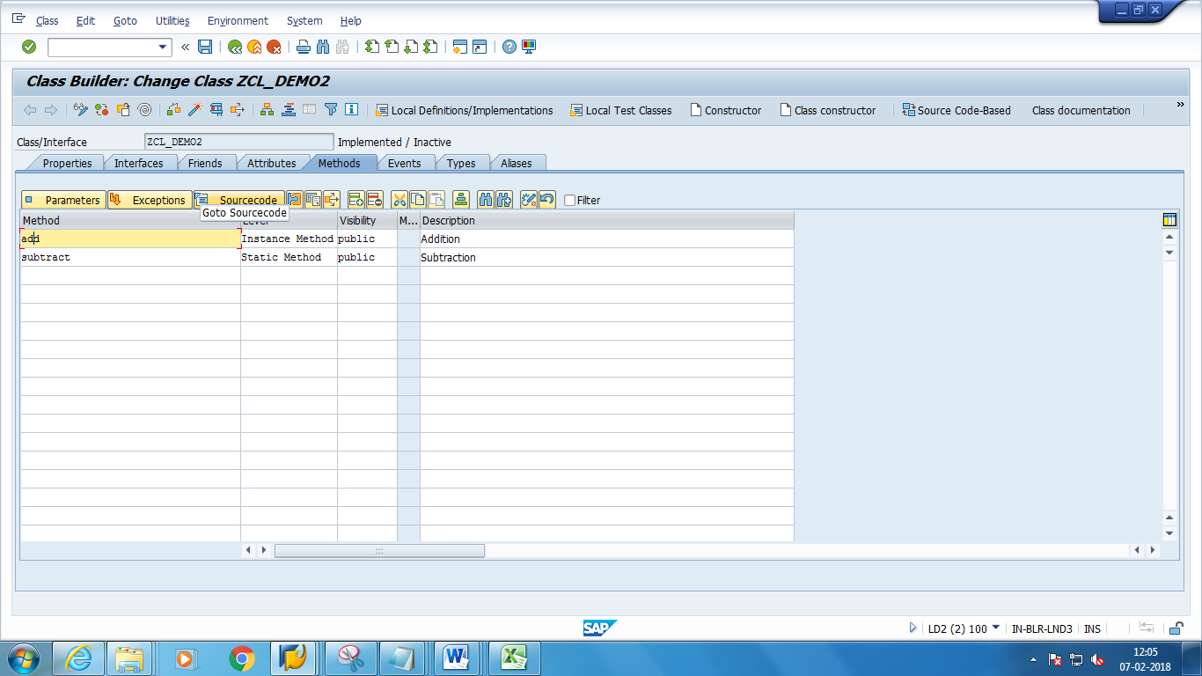

1. Add the below code in the method

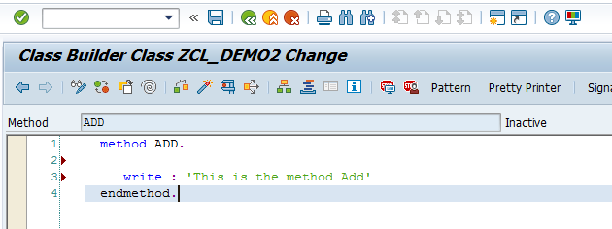

7) Similarly do for method Subtract and add the below code in Method Subtract.

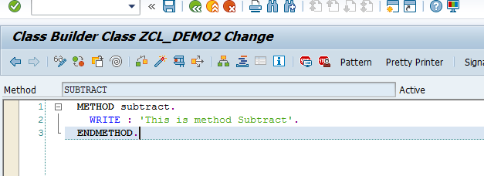

1. Save and activate the class.
2. Go to se38.Create a Report starting with Z
3. Add the below code in the Report.

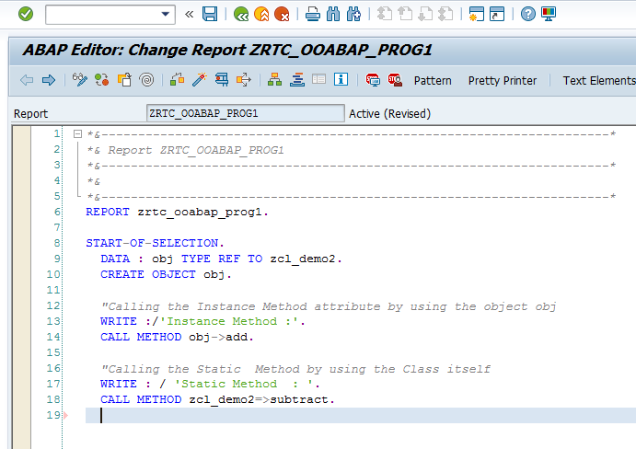

1. Save and activate. Execute. The expected output is as follows 